Keras

Link Video 1 Deep Learning Breakthroughts: <https://www.youtube.com/watch?v=iYdQ7bKBxFE>

Introduction video: <https://www.youtube.com/watch?v=-DZ5OI2uCzU>

Deep Learning Frameworks: <https://www.youtube.com/watch?v=i2mmnu-t8-c>

High Level Frameworks: <https://www.youtube.com/watch?v=ThmsQxazSvM>

Keras = sits on top of TensorFlow and provides a simplified interface,

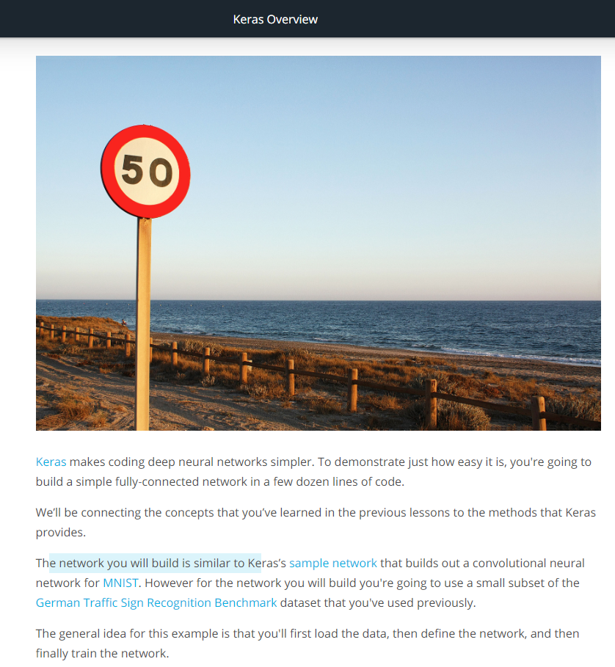

Link 1 Keras: <http://faroit.com/keras-docs/1.2.1/>

Line 2 Sample Network: <https://github.com/keras-team/keras/blob/master/examples/mnist_cnn.py>

MNIST: <http://yann.lecun.com/exdb/mnist/>

German Traffic Sign Recognition Benchmark: <http://benchmark.ini.rub.de/?section=gtsrb&subsection=news>

Neural Networks in Keras

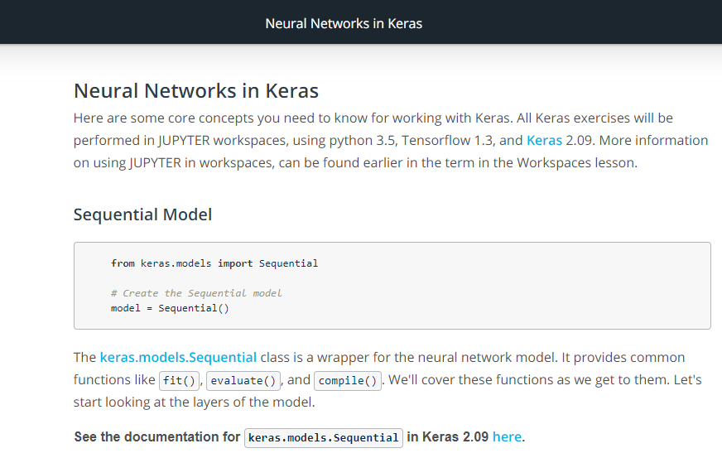

**Keras Sequiential:** <https://keras.io/models/sequential/>

<http://faroit.com/keras-docs/2.0.9/models/sequential/>

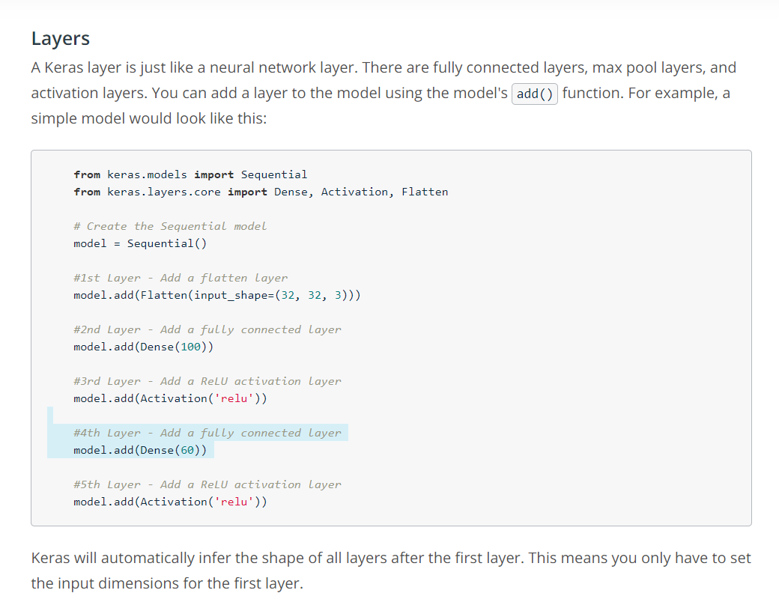

Infer = a deduce

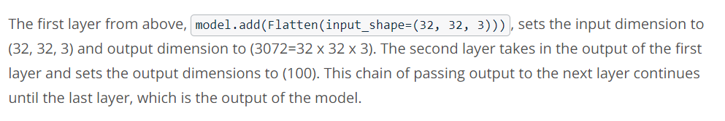

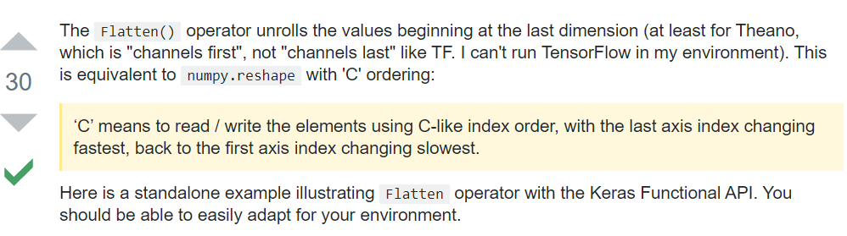

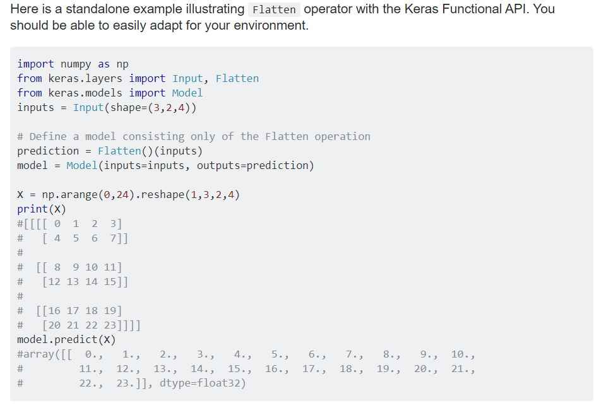

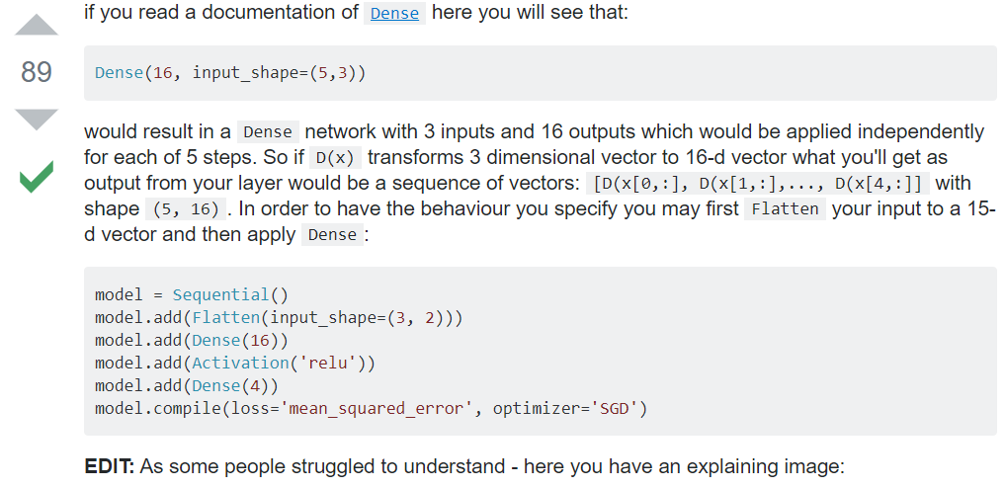

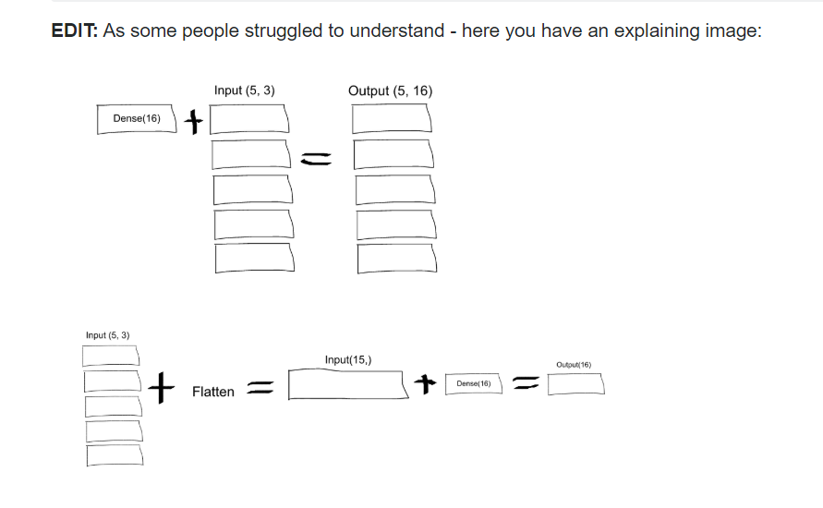

Revenim la curs…

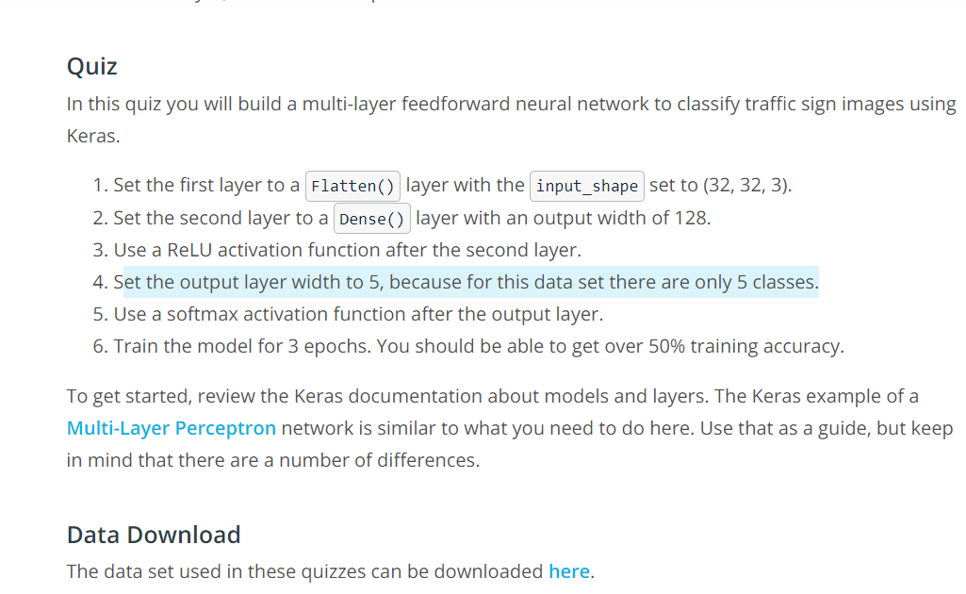

Data set link: <https://d17h27t6h515a5.cloudfront.net/topher/2017/March/58dbf6d5_small-traffic-set/small-traffic-set.zip>

Multi Layer Preceptron link: <https://github.com/keras-team/keras/blob/master/examples/mnist_mlp.py>

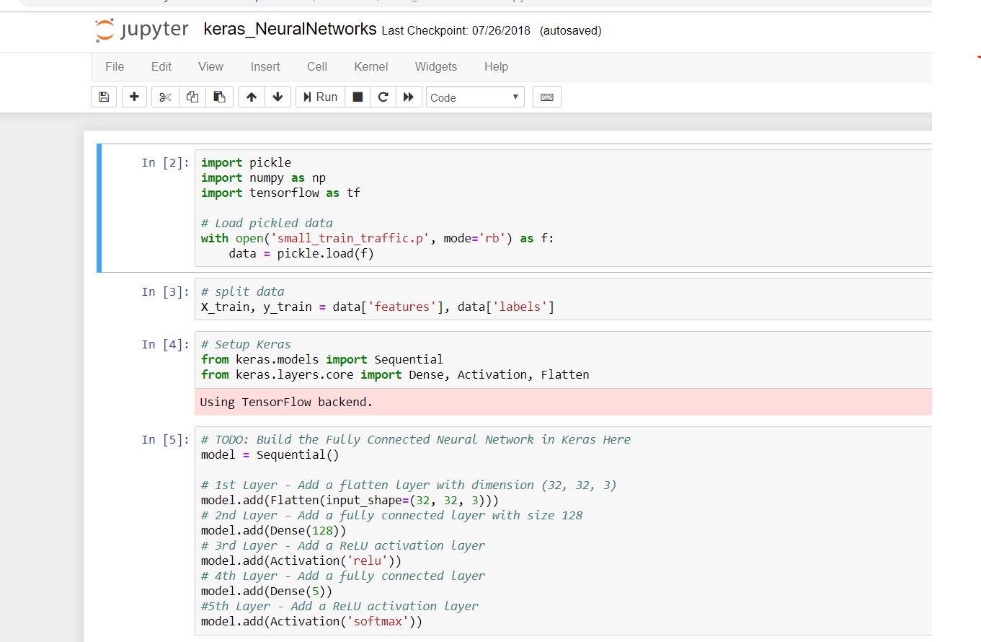

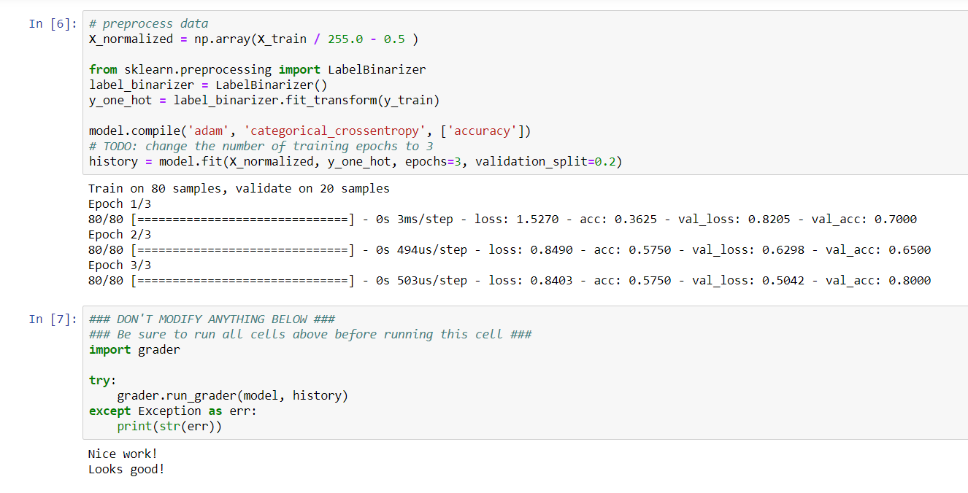

Convolutions in Keras

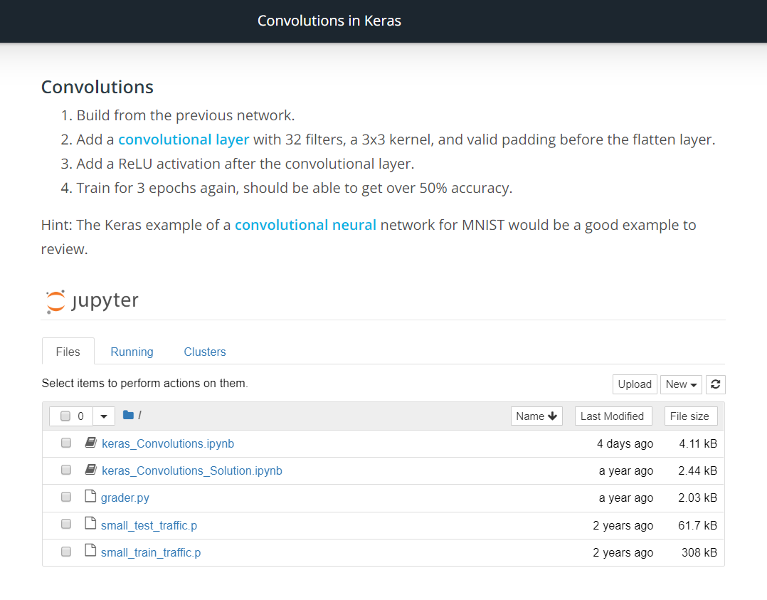

Link Convolutional Layer = <https://keras.io/layers/convolutional/#convolution2d>

Keras Example of a convolutional neural = <https://github.com/keras-team/keras/blob/master/examples/mnist_cnn.py>

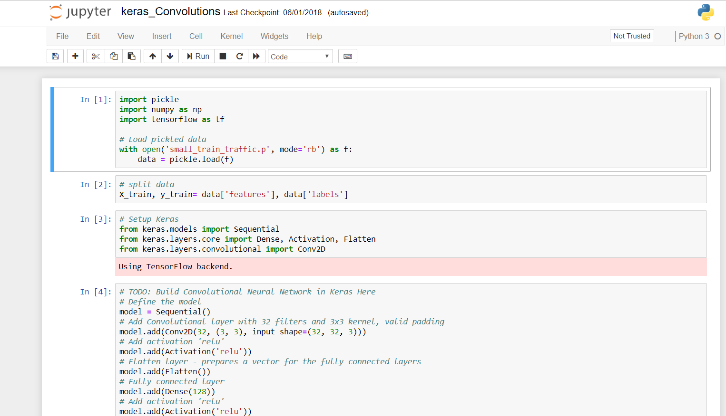

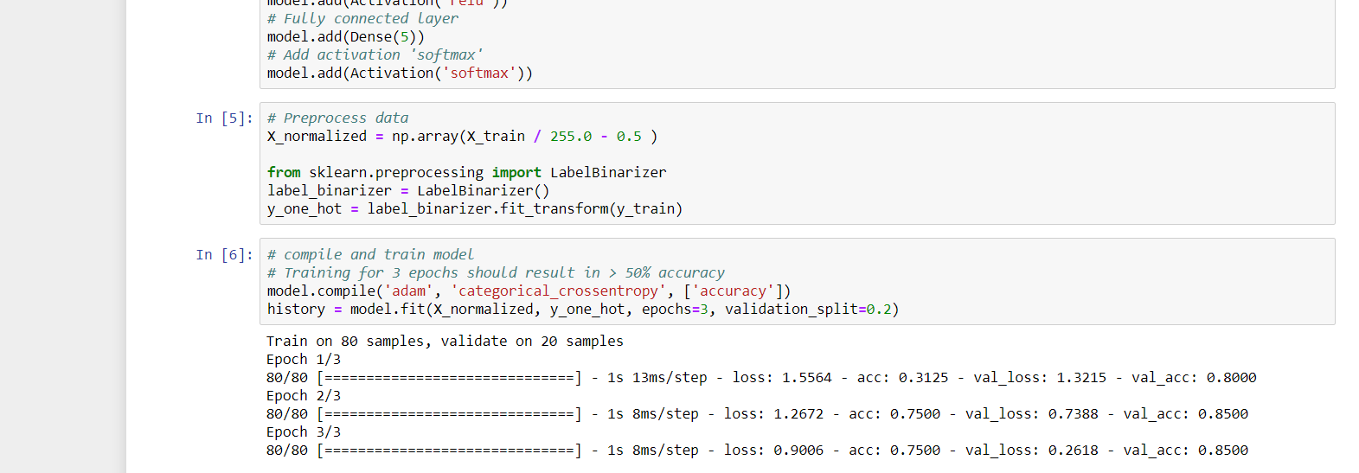

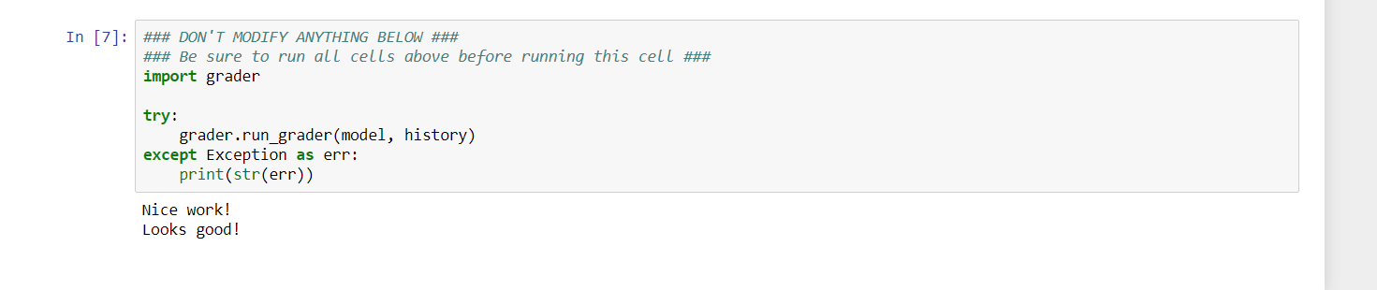

Pooling in Keras

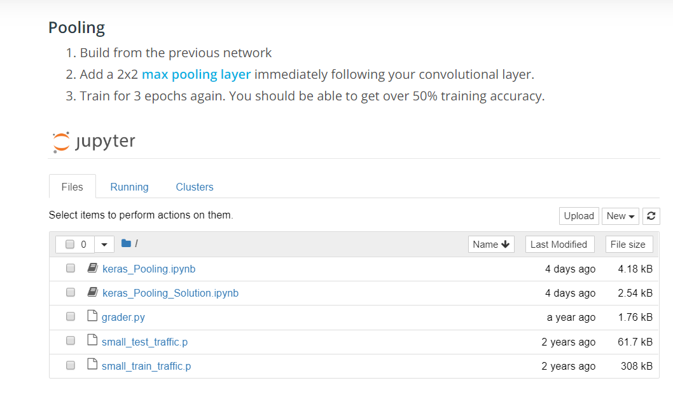

Link: <https://keras.io/layers/pooling/#maxpooling2d>

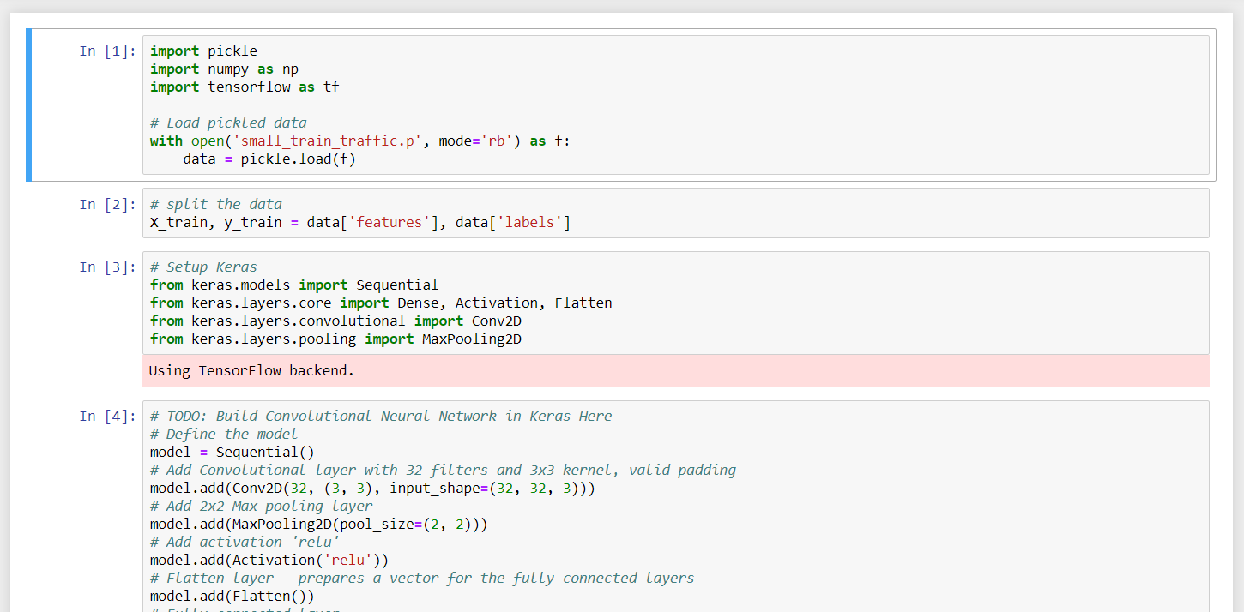

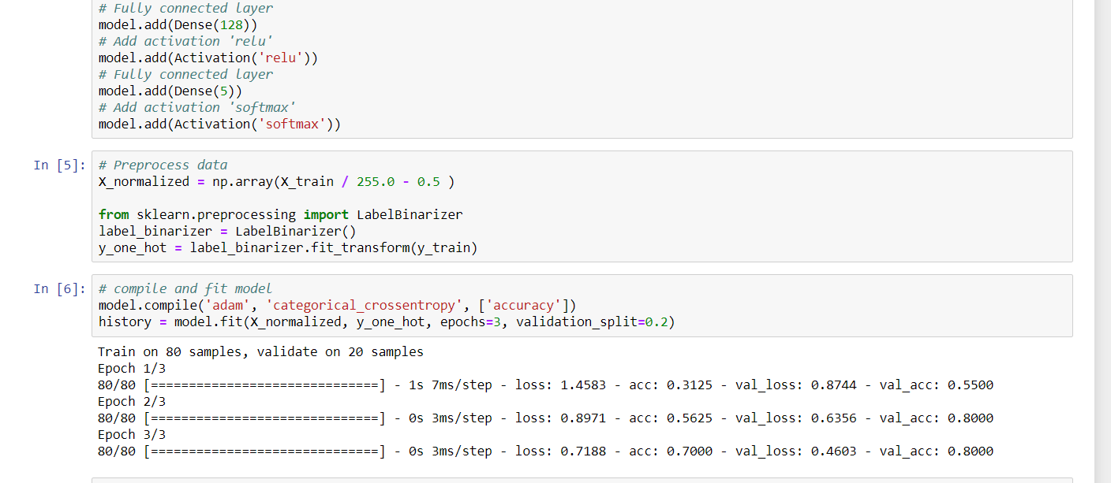

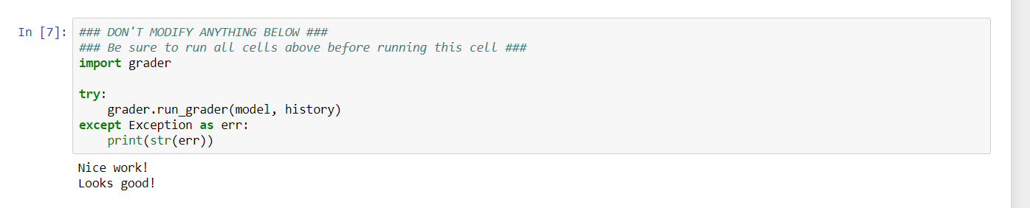

Dropout in Keras

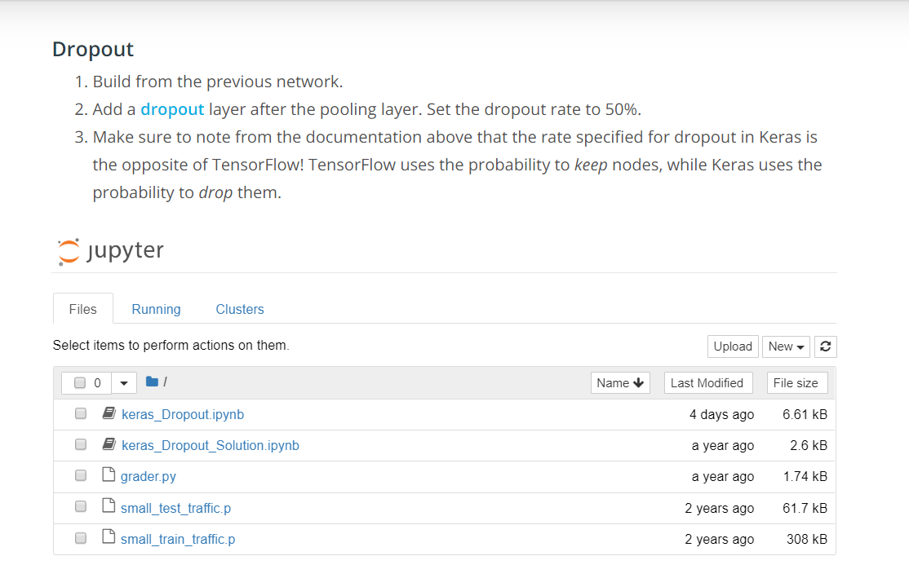

Link: <https://keras.io/layers/core/#dropout>

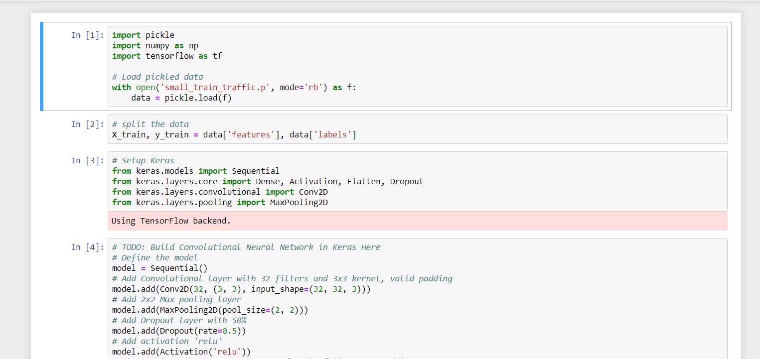

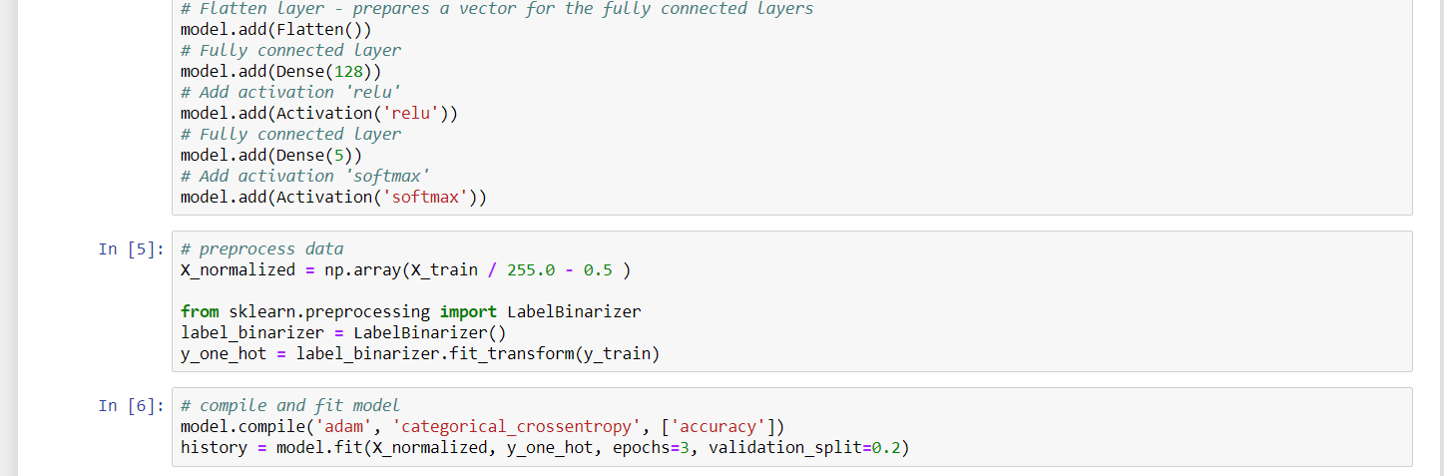

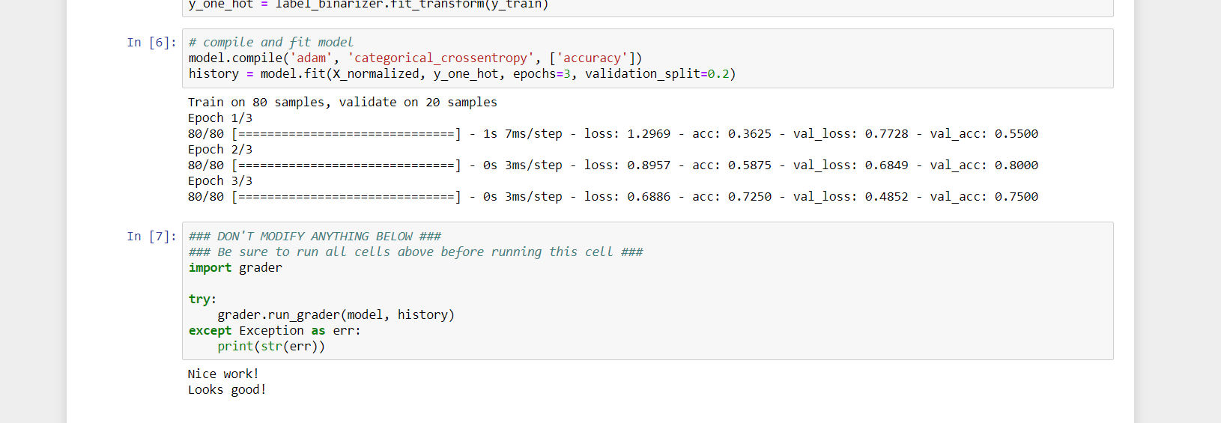

**Testing Keras**

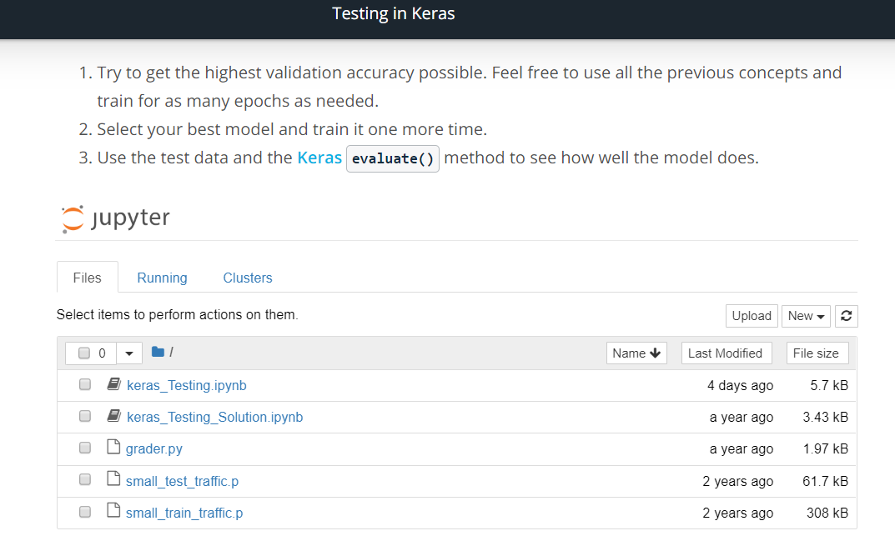

Link Keras evaluate = <https://keras.io/models/model/#evaluate>

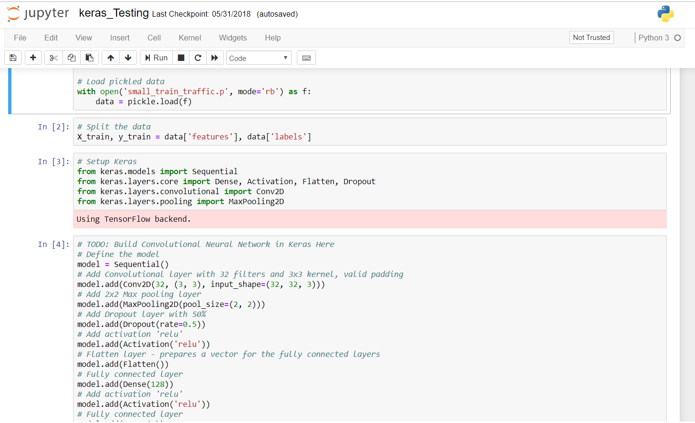

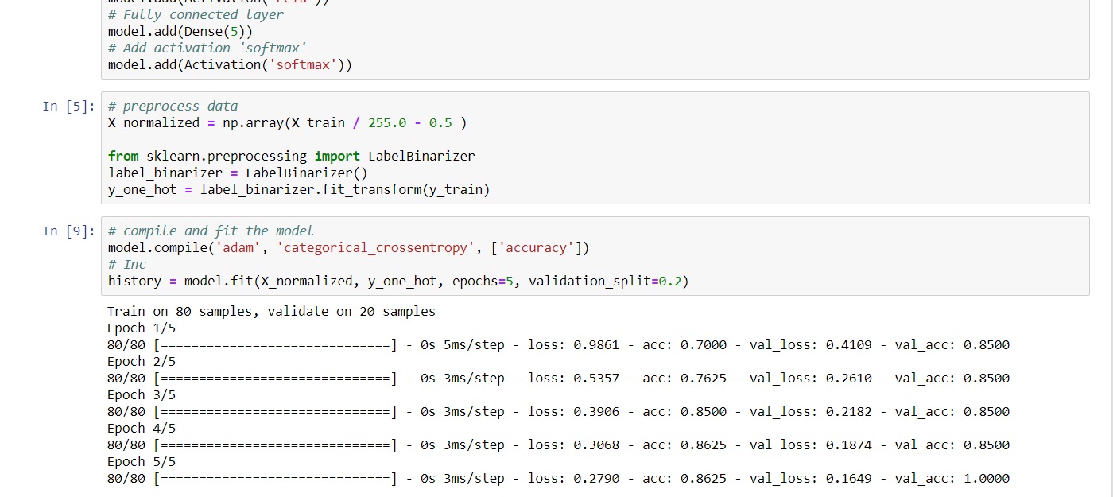

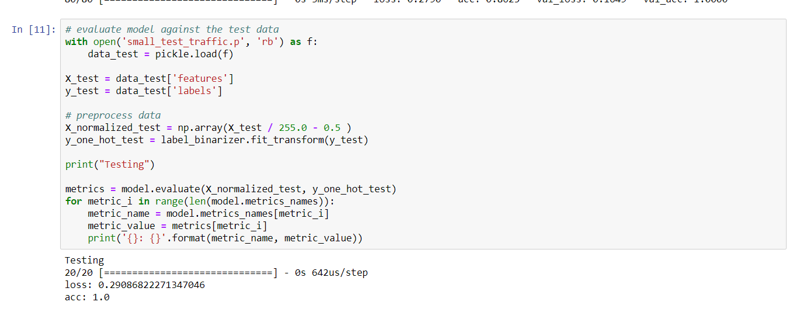

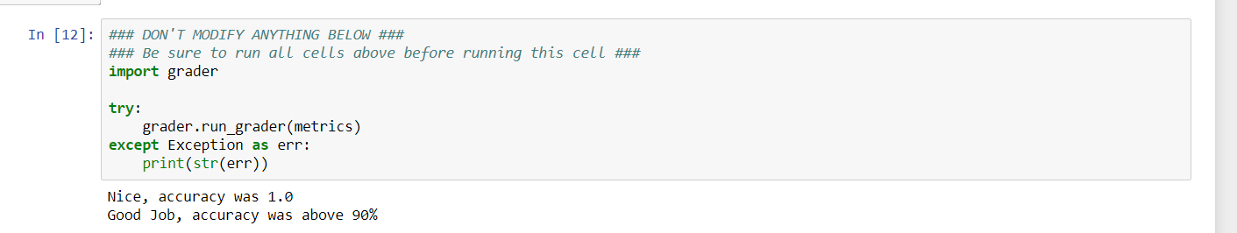

Link Conclusion: <https://www.youtube.com/watch?v=iLeQi96NRy0>